The International
Day of Peace
Observance


Friday, September 21, 2007
at 11:00 a.m.
Dominican Sisters of San Rafael
1520 Grand Avenue
www.sanrafaelop.org

Program

- Welcome
- Opening Prayer
- Hymn: Make Me an Instrument
- Community Sharing
All are invited to share briefly about your choice to attend.

- Prayers for World Peace
- Procession and Re-dedication of the Peace Pole
- Intercessory Prayer
All are invited to offer petitions for global peace.
Response: O God, hear us, hear our prayer.
- Presentation by the Children of St. Raphael School
- Prayer: The Lord’s Prayer for Justice
- Christian, Muslim and Jewish Prayers for Peace
- Hymn: Holy Ground
- Share the Sign of Peace

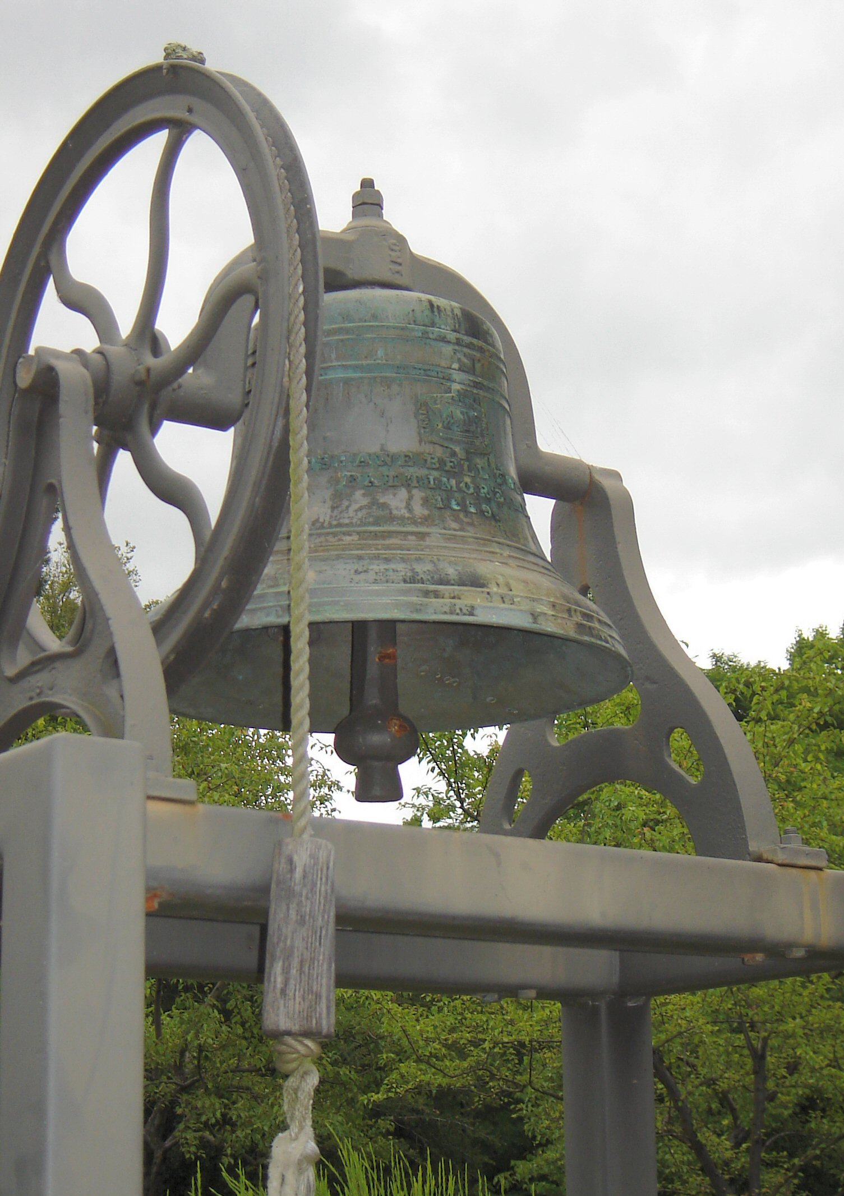

At noon we will toll the bell that has been
a call to prayer
for the Sisters in San Rafael
for over 100 years.

Please join us
and people all over the world
for a moment of silence.



OPENING PRAYER

Leader: Peace. I will reach into the still small point which is at the center of my soul and whisper PEACE, PEACE, until all the clamor of vain worlds cease and I emerge whole. (Kathy Keay)

ALL We believe in God, who is love and who has given the earth to all. We believe in Jesus Christ, who came to heal us, and to free us from all forms of oppression. We believe in the Spirit of God, who works in and through all who are turned towards the truth. We believe in the community of faith, which is called to be at the service of all. We believe in God’s promise to establish the kingdom of justice and peace for all.
Left We do not believe in the right of the strongest, nor the force of arms, nor the power of oppression.
Right We believe in human rights, in the solidarity of all people, in the power of non-violence.
Left We do not believe in the power that comes from wealth and privilege, or in any established order that enslaves.
Right We believe that all men and women are equally human, that order based on violence and injustice is not order.

Left We do not believe that war and hunger are inevitable and peace unattainable.
Right We believe in the beauty of simplicity, in love with open hands, in peace on earth.
ALL We do not believe that suffering need be in vain, that death is the end, or that the disfigurement of our world is what God intended. But we dare to believe, always and in spite of everything, in God’s power to transform and transfigure, fulfilling the promise of a new heaven and a new earth where justice and peace will flourish.

Hymn

Prayer of St. Francis

Make me a channel of your peace.
Where there is hatred, let me bring your love.
Where there is injury, your pardon, Lord.
And where there's doubt, true faith in you.

Make me a channel of your peace.
Where there's despair in life, let me bring hope,
Where there is darkness, only light,
and where there's sadness, ever joy.

Refrain: Oh Master grant that I may never seek
So much to be consoled as to console
To be understood as to understand
To be loved as to love with all my soul

Make me a channel of your peace.
It is in pardoning that we are pardoned.
In giving of ourselves that we receive
And in dying that we're born to eternal life.

Community Sharing:
What thought or feeling brought you to this gathering today?

PrayerS for WORLD Peace

[1]
May we be filled with the strength
to seek peace.
War will not end when the guns are silent.
Violence can never lead to peace.
May we be filled with the courage
to seek peace.
We grieve for the harm and the degradation
suffered here and in Iraq,
The contagion of fear and distrust,
The restriction of freedoms,
The quashing of dialogue and dissent.
We grieve the terrible wounding
of those sent off to fight in a war
that is questioned all over the world.
We grieve the rupture of families here and in Iraq.
May we be filled with the compassion
to seek peace.

We are members of one human family.
We grasp the horror of war in all its forms.
And we struggle to embrace the suffering of all
with love and compassion.
May we be filled with the endurance
to seek peace.
Recognizing our weakness
We call on the God of mercy and compassion
to guide us in the days ahead.
May we be filled with the vision
of peace.
from the Fellowship of Reconciliation Interfaith Prayer

[2]
Great God, who has told us “Vengeance is mine,”
save us from ourselves, save us from the vengeance in our hearts
and the acid in our souls.
Save us from our desire to hurt as we have been hurt,
to punish as we have been punished,
to terrorize as we have been terrorized.
Give us the strength it takes to listen rather than to judge,
to trust rather than to fear, to try again and again
to make peace even when peace eludes us.
We ask, O God, for the grace to be our best selves.
We ask for the vision to be builders of the human community
rather than its destroyers.
We ask for the humility as a people
to understand the fears and hopes of other peoples.
We ask for the love it takes to bequeath to the children of the world to come
more than the failures of our own making.
We ask for the heart it takes to care for all the peoples of Afghanistan and Iraq,
of Palestine and Israel, as well as for ourselves.
Give us the depth of soul, O God, to constrain our might,
to resist the temptations of power, to refuse to attack the attackable,
to understand that vengeance begets violence,
and to bring peace — not war—wherever we go.
For You, O God, have been merciful to us.
For You, O God, have been patient with us.
For You, O God, have been gracious to us.
And so may we be merciful and patient and gracious and trusting
with these others whom you also love.
This we ask through Jesus, the one without vengeance in his heart.
This we ask forever and ever. Amen.
by Joan D. Chittister, OSB

PROCESSION AND RE-DEDICATION
OF THE PEACE POLE

May peace prevail upon the earth.

Puiss la paix régner dans le monde.

Que la paz prevalezca en la tierra.



Intercessory Prayer
All are invited to offer petitions for global peace.
Response: O God, hear us, hear our prayer.

Presentation by the Children
of St. Raphael School
Kindergarten and First grade

The Lord’s Prayer for Justice
Our God who is in heaven
and in all of us here on earth
the hungry, the oppressed, the excluded,
Holy is our name.
May your reign come.
May your reign come and your will be done
in our choice to struggle with the complexities of this world
and to confront greed
and the desire for power in ourselves, in our nation
and in the global economy.
May your reign come.
Give us this day our daily bread,
bread that we are called to share,
bread you have given us abundantly
and that we must distribute fairly,
ensuring security for all.
May your reign come.

Forgive us our trespasses:
times we have turned away from the struggles
of other people and countries.
Times we have thought only of our own security.
May your reign come.

Lead us not into temptation,
the temptation to close our minds, ears and eyes
to the unfair global systems that create
larger and larger gaps between the rich and the poor
the temptation to think it is too difficult to bring
about more just alternatives.
May your reign come.

Deliver us from evil,
the evil of a world where violence happens in your name,
where wealth for a few is more important
than economic rights for all
where gates and barriers between people
are so hard to bring down.
May your reign come.
May your reign come, for yours is the kingdom, the power, and the glory forever and ever.
Grant us, Lord God, a vision of your world as your love would have it:
---a world where the weak are protected, and none go hungry or poor;
---a world where the riches of creation are shared, and everyone can
enjoy them;
---a world where different races and cultures live in harmony and
mutual respect;
---a world where peace is built with justice, and justice is guided by love.
Give us the inspiration and courage to build this world, through Jesus Christ our Lord. Amen.

A Christian Prayer for Peace
Blessed are the PEACEMAKERS,
for they shall be known as
the Children of God.
But I say to you that hear,
love your enemies,
do good to those who hate you,
bless those who curse you,
pray for those who abuse you.
To those who strike you on the cheek,
offer the other also,
and from those who take away your cloak,
do not withhold your coat as well.
Give to everyone who begs from you,
and of those who take away your goods,
do not ask them again.
And as you wish that others would do to you,
so do to them.

A Muslim Prayer for Peace
In the name of Allah,
the beneficent, the merciful.
Praise be to the Lord of the
Universe who has created us and
made us into tribes and nations,
That we may know each other, not that
we may despise each other.
If the enemy incline towards peace, do
thou also incline towards peace, and
trust God, for the Lord is the one that
hears and knows all things.
And the servants of God,
Most Gracious are those who walk on
the Earth in humility, and when we
address them, we say "PEACE."

A Jewish Prayer for Peace
Come let us go up the mountain of
the Lord, that we may walk the
paths of the Most High.
And we shall beat our swords into ploughshares,
and our spears into pruning hooks.
Nation shall not lift up sword against nation--
neither shall they learn war any more.
And none shall be afraid, for the mouth of the
Lord of Hosts has spoken.

HYMN

Holy Ground
(Sing three times.)

This is Holy Ground; we're standing on holy ground.
And the Lord is present, for where God is, is holy.
This is Holy Ground; we're standing on holy ground.
And the Lord is present, for where God is, is holy .





Endorsement of the Earth Charter

We, the Dominican Sisters of San Rafael, out of our care for Creation and in solidarity with our sisters and brothers of the Human-Earth-Global Community, endorse the Earth Charter and commit ourselves to use it to guide changes in our lifestyle and congregational decision making. We call ourselves to accountability through an annual update of our progress in the implementation of our endorsement of the Earth Charter.

June 2006

16. Promote a culture of tolerance, nonviolence, and peace.
a. Encourage and support mutual understanding, solidarity, and cooperation among all peoples and within and among nations.
b. Implement comprehensive strategies to prevent violent conflict and use collaborative problem solving to manage and resolve environmental conflicts and other disputes.
c. Demilitarize national security systems to the level of a non- provocative defense posture, and convert military resources to peaceful purposes, including ecological restoration.
d. Eliminate nuclear, biological, and toxic weapons and other weapons of mass destruction.
e. Ensure that the use of orbital and outer space supports environmental protection and peace.
f. Recognize that peace is the wholeness created by the right relationships with oneself, other persons, other cultures, other life, Earth, and the larger whole of which all are a part.

Excerpted from The Earth Charter
See www.earthcharter.org

Our Commitment to Peace in Iraq

In light of the escalating humanitarian crisis of the Iraqi people, the entrenched violence of the insurgency, and the plan by the President of the United States to increase the level of US troop presence in the country, the Dominican Sisters of San Rafael continue to express their concern for peace.

The time has come for genuine diplomatic and political solutions in Iraq. We urge the US Administration—in collaboration with the United Nations and the International Community—to seek a comprehensive cease fire by all factions in the country and to work with the Iraqi government on issues of national security, humanitarian aid, and reconstruction. We believe that regional conferences which addr3ess the conflicts in the Middle East may open new possibilities for peace in Iraq and we urge the US to participate with a genuine will to achieve peace.

We oppose the escalation of US troop levels and the presence of permanent US military bases. We urge Congress to oppose the Administration’s present policies and plans. It is time for the US government to yield authority to the Iraqi government, their police and military forces so that a planned withdrawal of US military forces from Iraq can begin. We continue to hold the United States Administration and Congress accountable for the ongoing suffering and death of innocent civilians in Iraq.

We urge the Administration and Congress to recognize that the Iraqi refugee situation, precipitated by the US invasion, has added to the destabilization of the entire region. Approximately 2 million Iraqis have fled their country since the inception of war in 2003. It is estimated that inside Iraq there are 1.8 million internally displaced people. We believe that the US government has a moral responsibility to acknowledge the crisis and create responsible immigration policies that offer opportunities for shelter and safety to innocent Iraqi citizens.

We support the Administration’s call for economic development in Iraq, which directly benefits the Iraqi people and their communities. We remain concerned about the protection of human rights, especially of women and religious minorities in Iraq.

Our support of our Dominican Family and the people in Iraq is sure and certain in the midst of an uncertain time. More than ever, our prayers are for peace. We pray for all those involved in the conflict, our Dominican brothers and sisters, the people of Iraq, the US occupying forces, Iraqi and international troops, humanitarian workers, and political leaders of the US and Iraq.

Authored by the North American Dominican Coordinating Committee on Iraq
Adapted and endorsed by the Dominican Sisters of San Rafael
March 19, 2007

What is the International Day of Peace?

In 1981 the United Nations General Assembly passed
Resolution 36/67 declaring an International Day of Peace.
In 2001, the United Nations General Assembly adopted a
new resolution, 55/282, declaring 21 September of each year
as the International Day of Peace.

The resolution: "Declares that the International Day of Peace
shall henceforth be observed as a day of global ceasefire and
non-violence, an invitation to all nations and people to honour
a cessation of hostilities for the duration of the Day...

“Invites all Member States, organizations of the United
Nations system, and non-governmental organizations and
individuals to commemorate, in an appropriate manner, the
International Day of Peace, including through education
and public awareness, and to cooperate with the United
Nations in the establishment of the global ceasefire.”

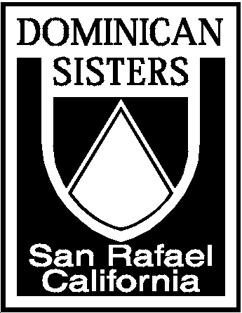

We, the Dominican sisters of San Rafael,
commit ourselves to the mission of Dominic:
to proclaim God’s Word in our world.

Called to discipleship through our vows
of poverty, chastity and obedience,
we follow Jesus according to
the Dominican apostolic life;
we pray, study, celebrate and live out
God’s Word in community.

With our lives thus centered in the Lord,
we seek to extend His mission
of truth and love in our ministry,
bringing the Gospel to bear
with depth and compassion
on the critical issues of our times.

