Human Cost of War Poster is below on page 2:

Instruction for updating:

Visit US Department of Defense and www.iraqbodycount.net regularly to update your sign numbers.
You can change the numbers by CAREFULLY clicking on the present numbers and changing them by editing them in Word. If you have trouble: use a blank page and type new numbers, print and cut and paste to the sign. The font is Arial 48pt. (this fits well into the space).

Scroll down to see the poster last updated 2/15/07

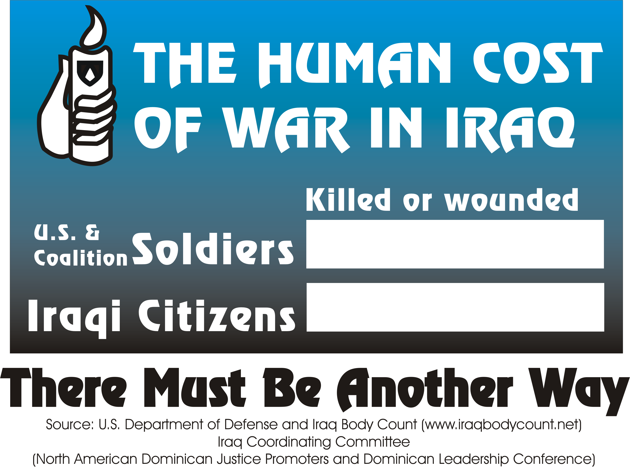

35,676
62,085

