800th Anniversary Logo
provided by the Dominican Leadership Conference
questions: contact Anne Lythgoe, OP
DLC Communications Coordinator
Please do not alter the design in any way and please attribute the source of this logo to the DLC.
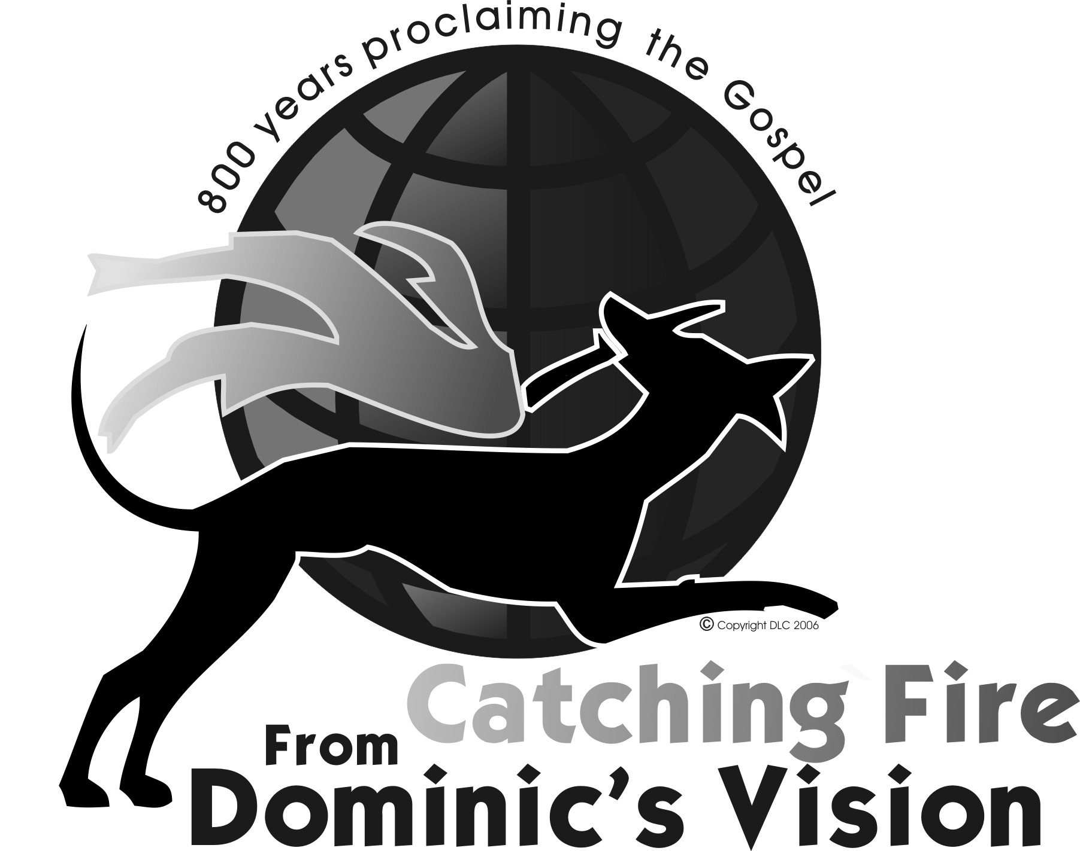 | GRAYSCALE  Print Friendly  approx 6x5 inches at 300dpi  Just click on the image and copy and paste to any Word friendly document. You can resize it by clicking on the image and using the corner bounding boxes.
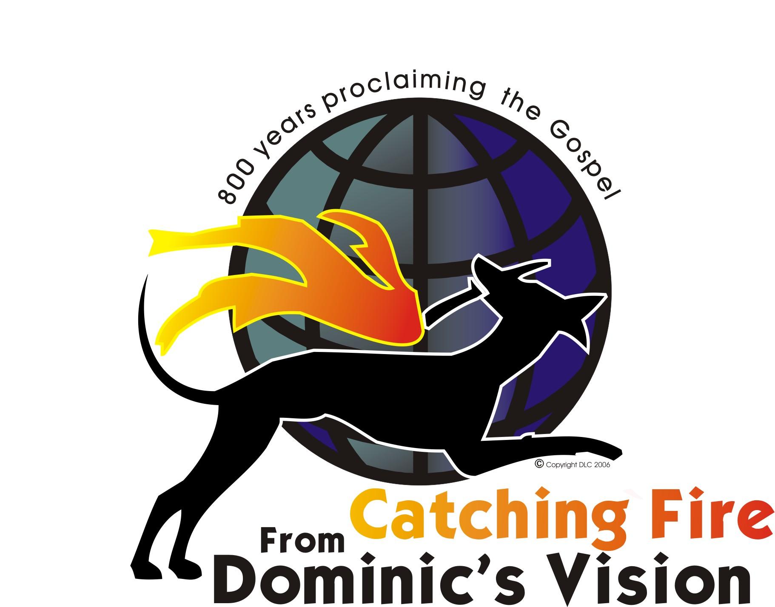 | Print Version COLOR  approx 6x5 inches at 300dpi  Just click on the image and copy and paste to any Word friendly document. You can resize it by clicking on the image and using the corner bounding boxes.
 | Web version  96 dpi  150px wide

