EARTH CARE TIPS

WATER
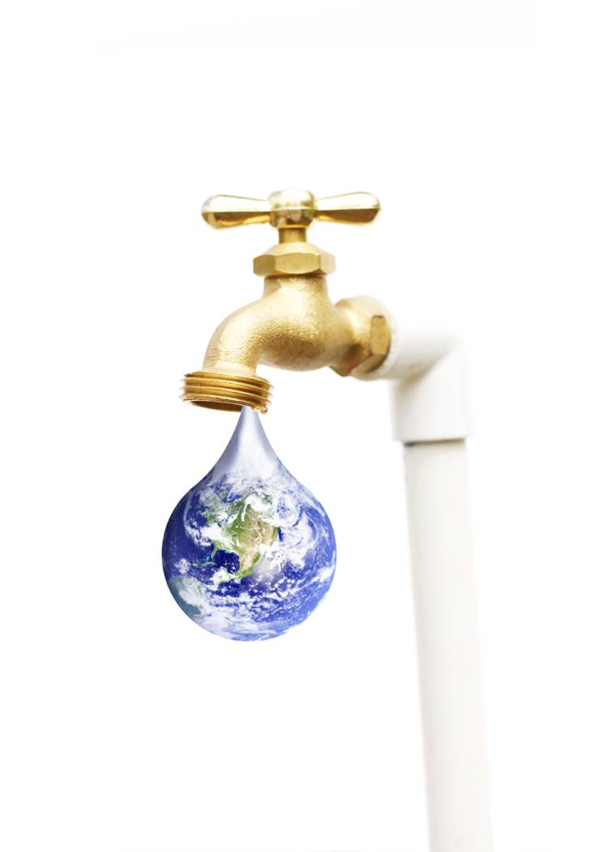
- Avoid bottled water. It costs 10,000 times more than tap water. Drink tap water in glasses or cups.
- Laundry: Run full loads with cold water and only oxygen bleach--not chlorine bleach.
- Do not let water run when hand-washing dishes; one tub for washing and one for rinsing; run dishwasher only when full.
- Take shorter showers. Use fewer flushes in personal bathrooms.
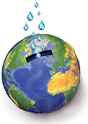
- Harvest water while waiting for it to run hot: from tub or shower, use for watering plants, flushing commodes; from kitchen, use for making coffee or tea, watering plants, providing water for pets, drinking water, or cooking.
- Cut back on lawn and flower watering or used harvested rainwater for plants or garden.
- Grow drought resistant plants and/or use “gray” water (previously used from dishes or laundry) for watering plants.

FOOD, KITCHEN, COOKING
- Coffee time: use unbleached or reusable coffee filters. White filters leach dioxin into our coffee and into our bodies.
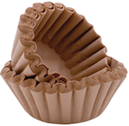
- Snack time: make popcorn in a brown paper bag or on the stovetop. Microwave popping bags have an unhealthy coating of non-stick chemicals.
- Eliminate Teflon© coated pans, turn off burner toward end of cooking time.
- Use the right sized pan for cooking and keep the lid on for most of the cooking time. Boil only amount of water you are going to consume.
- Cook meals from scratch. Commercial food processing creates three times as much carbon emission as home cooking.
- Select protein from sources other than meat and fish. Buy certified Fair Trade or Organic and locally grown, “green” products. Let store know how you are basing your decisions.
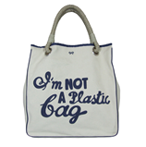
RECYCLE
- Recycling one glass bottle saves enough energy to power a computer for 30 minutes.
- Use cloth shopping bags instead of plastic or paper.
- Avoid disposables: Cover food with a dish, plate or lid instead of foil or plastic wrap; use hand towels instead of paper towels, etc.
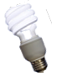
- Recycle everything!

POWER DOWN
- Go smaller: a 20-inch screen uses ten times less electricity than a fifty-inch screen.
- Unplug everything when not in use (lamps, televisions, computers, microwaves).
- Dust light bulbs. Clean bulbs work more efficiently. Use Compact Fluorescent light bulbs instead of incandescent bulbs.
- Replace existing appliances with Energy Star rated items. See www.energystar.gov .

INDOOR AIR QUALITY
- Home and office: have some houseplants around you. Plants clean the air by absorbing pollutants that are present in plywood, plastic, and adhesives. They also give off oxygen and provide mold-free humidity.

TRAVEL

- Use public transportation, carpool or combine trips.
- Keep car properly maintained.

For more information, and energy-saving tips go to http://www.epa.gov/ and www.energy.gov/

