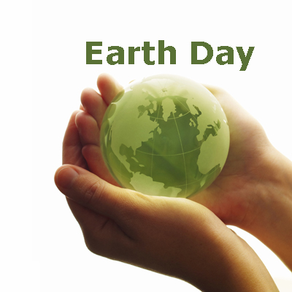

EARTH DAY APRIL 22, 2008

OPENING PRAYER:
Reader 1: How wonderful, 0 Lord, are the works of your hands! The heavens declare Your glory, the arch of sky displays Your handiwork.
All: The heavens declare the glory of God.
Reader 2: In Your love You have given us the power to behold the beauty of Your world, Robed in all Its splendor.
Reader 3: How wonderful, 0 Lord, are the works of your hands! The heavens declare Your glory, the arch of sky displays Your handiwork.
All: The heavens declare the glory of God.
Reader 4: In Your love You have given us the power to behold the beauty of Your world, Robed in all its splendor.
Reader 5: The sun and the stars, the valleys and the hills, the rivers and lakes, All disclose Your presence.
All: The Earth reveals God's eternal presence.
Reader 6: The roaring breakers of the seas tell of Your awesome might; The beasts of the fields and the birds of the air bespeak Your wondrous will.
All: Life comes forth by God's creative will.
Reader 7: In Your goodness You have made us able to hear the music of the world.
Reader 8: The raging of the winds, the whisperings of trees in the wood, and the precious voices of loved ones reveal to us that You are in our midst.
All: The Divine voice sings through all of creation.
READING:
Environmental rights are the rights of everyone to a secure, healthy and ecologically sound environment. Basic human rights such as the right to life, health and culture can only be enjoyed in a healthy and ecologically sound environment. Everyone has:
The Right to be consulted and included in any decisions affecting their environment.
The Right to accurate information concerning their environment.
The Right to express opinions and distribute Information on environmental issues.
The Right to education on the environment and human rights.
The Right to active and free participation in planning and decision making on the impact of any development that affects their environment.
The Right to associate freely and peacefully with others to protect the environment.
The Right to effective remedies and redress in administrative or judicial proceedings related to environmental harm or the threat of such harm.: UN declaration on Human rights and the environment 1994
REFLECTION
The earth is ultimately a common heritage, the fruits of which are for the benefit of all. Today, the dramatic threat of ecological breakdown is teaching us the extent to which greed and selfishness-both individual and collective-are contrary to the order of creation, an order which is characterized by mutual interdependence.
Pope John Paul 11, The Ecological Crisis: A Common Responsibility, 1990
Response: Help us respect, restore and renew the earth, O Lord.
PRAYER OF COMMITMENT
We commit ourselves to care for all the gifts of Creation. We commit ourselves to explore and understand environmental concerns. We commit to work with others for environmental justice for all. Come Holy Spirit; enkindle in us the fire of your love. Send your breath over the waters and we shall be re-created. And we shall renew the face of the Earth.
ENDING PRAYER
We pray for the waters of the rivers, That through God's grace we will fill them again with bountiful life.
We pray for the soil of the earth, That through God's grace we will work for abundant harvests for all.
We pray for the birds of the trees, That through God's grace we can offer them sheltering green leaves.
We pray for all of this sacred earth, that through God's grace and with God's help we will renew the music of creation's pulsating life.
159 Washington Blvd, P. O. Box 3248, Mission San Jose, CA 94539-0324 (510) 624-4500 Copyright © 2008 Sisters of the Holy Family, All Rights Reserved.

