March 24, 2007
Anniversary of the Assassination of Archbishop Romero

Our Dear Brother Jon,

You are in our minds and in our hearts these days. We write at this time to offer our support. Please know how important your study, reflection, writing and teaching have been to us. We are grateful especially for your advocacy for the least of our sisters and brothers.

We are greatly saddened by the recent action of the Congregation for the Doctrine of Faith in relation to your theological work.

It was a great honour for us to meet you at the January 2007 “World Forum on Liberation and Theology” in Nairobi. Thank you for your generous and faithful service to God’s people.

With Affection and Admiration,
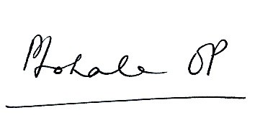


Fr. Prakash Anthony Lohale, OP Sr. Toni Harris, OP
General Co-Promoters for Justice and Peace

